**NAAN MUDHALVAN**

**ASSIGNMENT DOCUMENT**

**COURSE TITLE** : DIGITAL MARKETING

**COLLEGE CODE** : 1105

**COLLEGE NAME** : GOJAN SCHOOL OF BUSINESS AND TECHNOLOGY

**NMID**:5E3431D1589F6A88E8149456869834D3

**NAME** : LOGESH A

**REGISTER NUMBER** : 110520106007

**YEAR** : 4TH YEAR

**DEPARTMENT** : ELECTRONICS AND COMMUNICATION ENGINEERING

1. Create a blog or website using Blogspot and Wordpress. Customize the theme design and post new article with 500 words.

Link[:https://affilatedmarket1612.blogspot.com/2023/10/affilated-marketing.html](https://affilatedmarket1612.blogspot.com/2023/10/affilated-marketing.html)

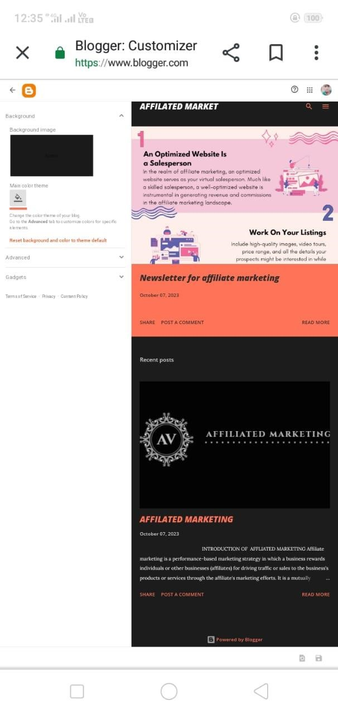

2.Create a New Facebook Business Page and post one social media poster for your brand.

Link: https://www.facebook.com/profile.php?id=61552066803880&mibextid=ZbWKwL

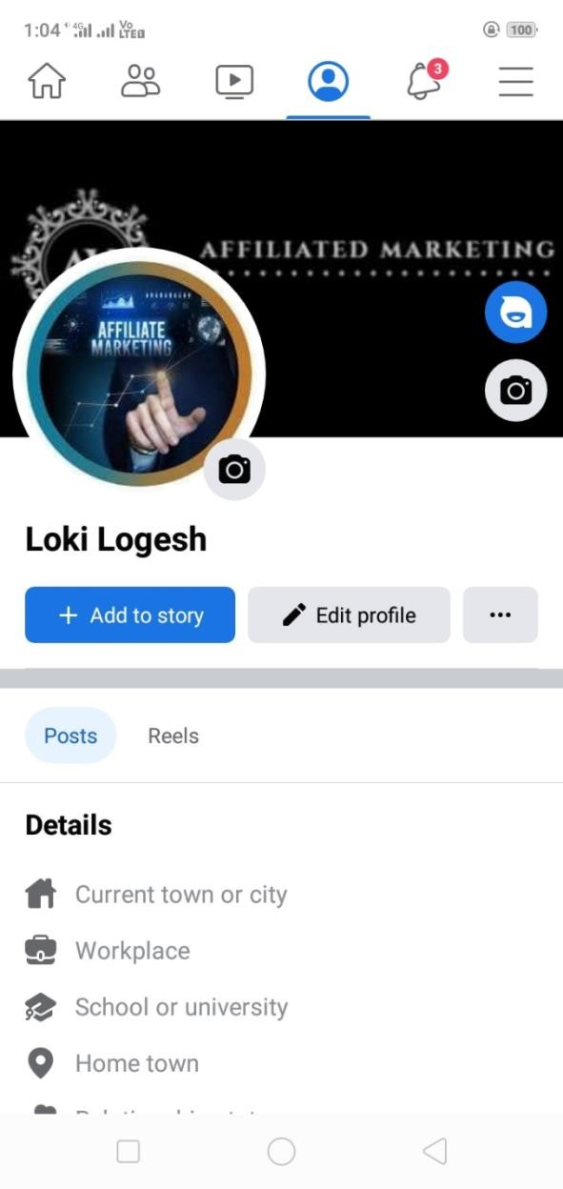

3.Create and design a social media advertisement poster using canva.



4.Create email newsletter design using MailChimp or canva tool.

Link: [https://affilatedmarket1612.blogspot.com/2023/10/newsletter-for-affiliatemarketing.html](https://affilatedmarket1612.blogspot.com/2023/10/newsletter-for-affiliate-marketing.html)

